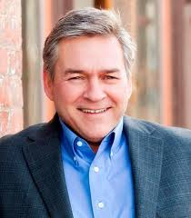**Randy Bridges**: Freshman Rep. Republican from Paducah McCracken Co. **(3rd District)**, mid 60’s married for 38 years to Carla (teacher of 27 years). Owned (partner) in convenience store chain for roughly 30 years, before selling to his partner. Since has started a property development and management firm as well as being a partner in the local Remax agent. 2 kids, 4 grandkids. Local, born and raised. Dad was a plumber, thus humble beginnings. In a debate with his opponent he mentioned his wife a teacher, and how disenchanted she, as well as many of her contemporaries were with the current pension system, even it was functional. His proposal is the hybrid 401k plan. He was also critical of higher education as it is currently structured. He believed the cost was too high because institutions of higher learning, i.e. colleges and universities are allowed to “over expand” and spend money on student recruitment instead of education, where they should be spending money, thus driving up the cost. His biggest issues are economic and the future of young people and business in the commonwealth, as well as public education and the pension issue. He is a huge proponent of privatization of public pension.   
Primary Sponsored Legislation: HB: 436 & 438  
Cosponsored Legislation: HB: 1, 5, 28, 29, 62, 148, 150, 197, 262, 263 & 273

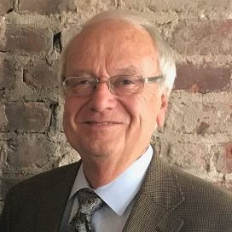**Larry Elkins**: Freshman Rep. Republican from Murray **(5th District)**, 66, served 5 terms as Murray Judge Exec, before that he was police chief. Army vet who has always worked in the public sector. Married with 3 children. Born and raised in Calloway Co, and MSU Alum. He is taking over a vacant seat. (Note the 5th District also has part of Trigg Co.) He started out as a registered Dem, switched to, ran and was elected as an independent and then in 05 went Republican. He is incredibly fiscally conservative and claims to hold a stance of refusal to make a decision on anything before reading it.   
Primary Sponsored Legislation: HB: 335  
Cosponsored Legislation: HB: 1, 5, 25, 26, 28, 38, 60, 62, 66, 84, 136, 148, 168, 197, 198, 216, 245, 251, 311, 316, 358, 384, 388, 389, 390, 406 & 476

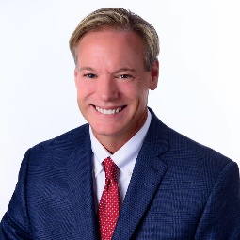**Chris Freeland**: Freshman Rep. Republican from Benton **(6th District)**, served on the Benton City Council for several terms, won against a woman and is taking over for a Democrat (Will Coursey, who is now the Marshall Co Judge Exec). Freeland owns a couple of radio stations in Marshall Co and surrounding area. Had run for the seat before and lost. Consistently active in the community and area. Is married to Lori Peterson, a dental hygienist. They have 2 children. Ran as “the outsider business candidate”.  
Primary Sponsored Legislation: HB: 1, 223, 259, 291 & 399  
Cosponsored Legislation: HB: 5, 13, 21, 25, 28, 29, 62, 66, 136, 139, 148, 197, 203, 229, 273, 358 & 383

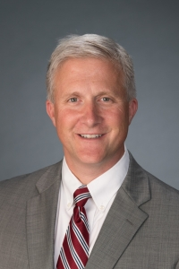**Robert Wiederstien**: Freshman Rep. Democrat from Henderson **(11th District)**, served as district judge for nearly 20 years. Prior to that he was a real estate attorney with some insurance defense peppered in. He is from Louisville originally, and has a law degree from IU. Wife, Cathy, is also an attorney. They have 2 adult children. Seems to be a typical attorney style Democrat. Seems to approach things very academically, but for the most part, based on what I have read is an incredible party loyalist.   
Cosponsored Legislation: HB: 62, 136, 247, 253, 261, 307, 322, 401

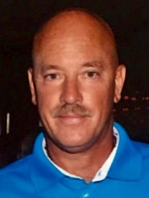**Scott Lewis**: Freshman Rep. Republican from Hartford **(14th District)**, Ohio Co and a little bit of Daviess Co. Has served as Ohio Co Superintendent for the last 6 years and was Hancock Co superintendent before that. He was a principal and teacher, and at one point briefly before he entered education a state trooper. He also owns several Subway restaurants. Has 3 kids and 2 grandsons. Late 50’s. He is a big proponent of police issues as well as education. Very much marches to the beat of his own drum.  
Primary Sponsored Legislation: HB: 490 & 504  
 Cosponsored Legislation: HB: 5, 58, 84, 86, 148, 383, 406 & 436

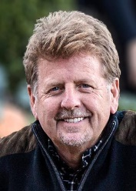**Steve Sheldon**: Freshman Rep. Republican from BG **(17th District)**. Sheldon owned and operated several local pharmacies in BG for the last 30 years. Very pro small business. He and his wife are also land developers in the area. Sheldon is not a local, he was born to a military family in England and grew up in South Carolina until his father passed away and he and his mothered moved to Owensboro. He went to WKU on a war orphan’s scholarship. He has 5 children. He and his wife are founders and very involved and proud of a local mobile ministry in the BG area. He is big on healthcare and economics.  
Primary Sponsored Legislation: HB: 99, 170, 204, 215, 216, 217, 218, 224, 243 & 342  
Cosponsored Legislation: HB: 1, 2, 5, 11, 25, 36, 37, 46, 60, 61, 62, 64, 78, 84, 86, 93, 100, 115, 121, 136, 148, 166, 237, 241, 274, 351, 354, 383, 406, 423, 436, 513, 517 & 522

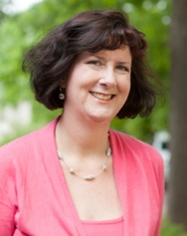**Patti Minter**: Freshman Rep. Democrat from BG **(20th District)**. Minter is a life long educator. College professor at WKU. Teaches history. From a farm and teaching family in East TN. And a UT Alum. Based on her campaign she is very far left and a social justice warrior, a true believer. She seems to be on the war path for pensions and securing as much money as possible, via higher taxes, for education.   
Primary Sponsored Legislation: HB: 164   
Cosponsored Legislation: HB: 17, 23, 24, 25, 44, 50, 62, 64, 83, 85, 112, 113, 115, 126, 136, 155, 162, 211, 247, 253, 261, 307, 322, 351, 383, 401, 406, 438, 447 & 488

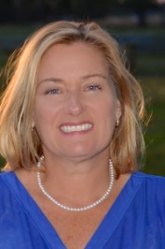**Nancy Tate**: Freshman Rep. Republican from Brandenburg **(27th District)** Meade and a little of Breck Co. States that being a fiscal conservative is a priority, however her platform and history seems to be all pro-life hard right-wing. However, it seems that she is playing to her audience. UPS employee of over 20 years and mother of 3. She worked her way up the ladder at UPS to a high-ranking corporate position. She is clearly very sharp. Won a super close race against the incumbent Dem Jim Greer, won by 6 total votes. Board member of her church. Again, she ran on a narrow platform, but she is clearly very smart. Based on some interviews she would seem to be a rather shrewd deal maker.   
Primary Sponsored Legislation: HB: 5, 100, 148, 423 & 513  
Cosponsored Legislation: HB: 1, 11, 27, 28, 60, 66, 68, 115, 153, 160, 162, 197, 324, 351, 383, 436 & 488

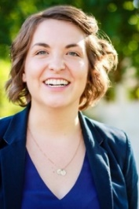**Josie Raymond**: Freshman Rep. Democrat from Louisville **(31st District)** East Louisville Replacing long time Dem, Steve Riggs. Louisville and HP native. Ivy League educated at Columbia, and Manual Alum. Has spent most of her life in education, currently at UofL. Married to Adam with 2 kids, boy and girl, Curt and Pippy. Ran strong on labor and wage issues along with far-left social justice issues. “Generate new revenue to fully fund pensions, starting with the Commonwealth's wealthiest residents paying their fair share of taxes.” From her campaign website. She can hold that seat forever if she wants based on that district and the way it is swinging.   
Primary Sponsored Legislation: HB: 112, 113, 231 & 376  
Cosponsored Legislation: HB: 17, 23, 24, 41, 47, 48, 62, 85, 91, 126, 136, 155, 162, 164, 182, 202, 211, 261, 322, 401, 426 & 447

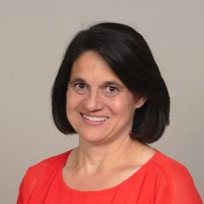**Tina Bojanowski**: Freshman Rep. Democrat from Louisville **(32nd District)** Hurtsbourne/Lyndon. Beat the incumbent Phil Moffet. She has a PhD in education and teaches special ed. 2 kids (adults) and married. Seems to be fairly center/left. She seems to be an open minded and fair person, as it pertains to the issues. As she is an educator, education will be a primary issue for her. Again, not way far left, seems to be fairly moderate.   
Primary Sponsored Legislation: HB: 447 & 461  
Cosponsored Legislation: HB: 8, 17, 23, 24, 25, 62, 70, 76, 85, 112, 113, 115, 136, 155, 157, 162, 164, 202, 211, 236, 261, 307, 310, 322, 350, 361, 401 & 462

**Lisa Willner**: Freshman Rep. Democrat from Louisville **(35th District)** Audubon Park. Taking over for Jim Wayne (Dem). Willner is another Ivy Leaguer, Yale Alum. Exec Director KY Psych Association as well as being a faculty member at Bellarmine, and member of the Jefferson Co BOE. Has a PhD from Cal in psych. Married to John, didn’t take his last name… and has two adult children. Comes off as far left, has a 14 point action plan on her website, most of which include public pension protection, education, **environment**. She could be a big help on buses, especially coming out of Jefferson Co. Outside of that she seems real left. She is going to be the mental health expert on the “School Safety Bill”.  
Primary Sponsored Legislation: HB: 126, 202, 211, 438 & 485  
Cosponsored Legislation: HB: 11, 17, 23, 24, 25, 62, 64, 70, 76, 83, 85, 112, 113, 115, 136, 155, 158, 162, 164, 202, 224, 237, 247, 253, 261, 307, 322, 323, 350, 361, 401, 447 & 488  


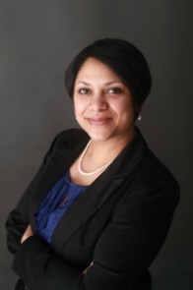**Nima Kulkarni**: Freshman Rep. Democrat from Louisville **(40th District)** Central Louisville. Taking over for Dennis Horlander (Dem). She is an immigrant from India, moved here with her parents at age 6. She is an attorney by trade, and subsequently a small business owner, as she is the primary at the firm, Indus Law, which specializes in immigration law and employment. She has a partner Raegan. She beat Horlander in the primary. Look for her to be super engaged and into everything. Again, left leaning Dem.  
Primary Sponsored Legislation: HB: 236, 447, 461 & 462  
Cosponsored Legislation: HB: 17, 23, 24, 62, 85, 112, 113, 115, 126, 136, 155, 162, 164, 211, 247, 253, 261, 307, 310, 322, 350, 361 & 401

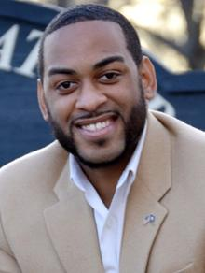**Charles Booker**: Freshman Rep. Democrat from Louisville **(43rd District)** West Louisville. Taking over Darryl Owens (Dem). He is married and has 2 young daughters. Has a law and under grad degree from UofL. Has spent his relatively short career in the public sector in a number of appointed positions. Tied firmly to the Democratic party of Louisville with strong ties to Yarmuth and Fisher. Really big on civil rights and social justice, but beyond that economic development is a huge issue. Really sharp young guy, he will work with you on the right ideas.  
Primary Sponsored Legislation: HB: 91, 92, 155, 232, 233, 234, 235, 236, 265, 372, 404, 405, 451, 452, 464, 466, 467, 511 & 512  
Cosponsored Legislation: HB: 11, 16, 17, 23, 24, 25, 50, 60, 62, 64, 70, 76, 83, 85, 112, 113, 115, 126, 136, 159, 164, 190, 211, 247, 253, 261, 307, 322, 376, 401 & 438

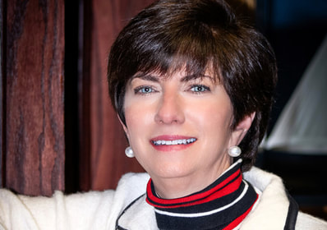**Maria Sorolis**: Freshman Rep. Democrat from Louisville **(48th District)** WEALTHY East Louisville. Beat the Republican, one term Rep. Ken Fleming. She is a mother of 3 and a practicing attorney as well as a teacher. She seems to be big on education, but it is hard to tell as she doesn’t seem real clear on any issue. Be friendly, as always never know when you will need a vote. Owns her own firm currently.  
Primary Sponsored Legislation: HB: 247, 253, 363, 364, 432, 433 & 434  
Cosponsored Legislation: HB: 17, 21, 23, 24, 25, 62, 83, 88, 112, 113, 126, 136, 155, 157, 162, 164, 172, 211, 261, 307, 310, 322, 350, 361, 400, 401 & 448

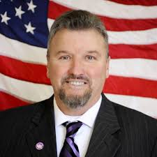**Thomas Huff**: Freshman Rep. Republican from Shepherdsville **(49th District)**. Beat incumbent Linda Belcher (Dem). Belcher had previously lost the seat and in a series of strange events won it back. Huff own’s a small car dealership as well as salvage yard. Seems to stick to far-right issues, which plays to the majority of that district. Could be good for Small Business. Has a number of lumber dealers in his district.

Primary Sponsored Legislation: HB: 240  
Cosponsored Legislation: HB: 5, 62, 84, 115, 117, 148, 200 & 327

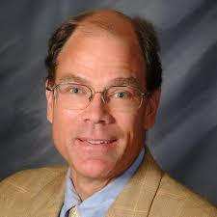

**Joe Graviss**: Freshman Rep. Democrat from Versailles **(56th District)** Parts of Fayette, Franklin and Woodford Co. Joe won an election by double digits. He is replacing James Kay (Dem), who is now the Woodford Co Judge Exec. Graviss owned and operated 9 McDonald’s franchises in the Greater Lexington area, as well as being incredibly involved in local civic causes and activities, sitting on countless boards over the years. Issues seem to be pensions, tax reform, education and jobs. He is married, but no children are mentioned. His wife owns a small business, a graphic design firm in Midway that also makes greeting cards.  
Primary Sponsored Legislation: HB: 230, 307, 308, 367 & 401  
Cosponsored Legislation: HB: 1, 9, 11, 17, 25, 27, 28, 36, 37, 58, 60, 62, 70, 76, 83, 84, 93, 112, 113, 115, 126, 136, 139, 155, 157, 158, 162, 197, 209, 224, 225, 247, 253, 261, 280, 292, 311, 322, 361, 371, 378, 383 & 482

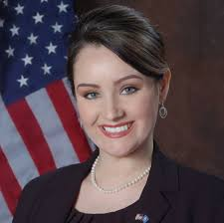**Savannah Maddox**: Freshman Rep. Republican **(61st District)** Grant Co (NKY). Maddox is taking over for Brian Linder (Rep) who decided not to seek reelection after a sexual harassment scandal. Maddox is married with 2 young children (boy and girl). Maddox is the Chair of the Grant Co Rep Party as well as the NKY Young Republicans. Politics and the party seem to be her profession. Based on interviews and articles stands firm on the party line. As she is a NKY resident and a firm Republican. Need to get to know her.  
Primary Sponsored Legislation: HB: 222, 254, 327, 398 & 430  
Cosponsored Legislation: HB: 5, 97, 136, 148, 160 & 358

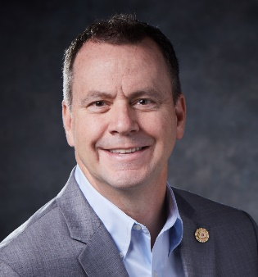**Charles “Buddy” Wheatley**: Freshman Rep. Democrat **(65th District)** Covington KY (Kenton Co). He is taking over for a retiring Arnold Simpson (Dem). Buddy has had several careers. NKU alum, started out as a journalist for a couple of area newspapers. Then, as it was a family tradition, he joined the fire department, eventually rising the rank of chief. During his time in the FD he was the local union rep. While chief of the fire dept he attended and graduated from NKU Law (Chase). After that he started a private practice specifically representing public sector labor unions in employment cases. He has an active Twitter account and a habit of actively calling out other member of the GA, example: @buddywheatleyky “Tell Rep. Upchurch and the GOP that the current pension obligation may actually be increased by the proposed legislation. We just don’t know without a fiscal note. And then more than $10,000 per Kentuckian will be owed.” His biggest issues are pensions and public employees. He seems to be an older school Dem, in that he is all union, represents the worker, seems to take issue with management and wealth.   
Cosponsored Legislation: HB: 11, 12, 13, 15, 17, 23, 24, 27, 40, 44, 75, 85, 106, 112, 115, 126, 136, 155, 164, 175, 180, 190, 211, 239, 247, 253, 273, 301, 307, 322, 353*, 383, 401 & 406

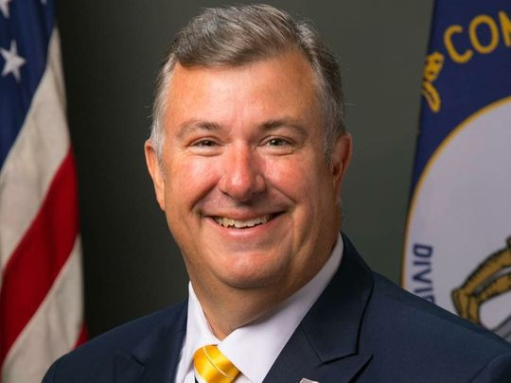**C. Ed Massey**: Freshman Rep. Republican **(66th District)** Norther Boone Co. He is an attorney by trade and a primary partner in his firm. He is taking over for Addia Wuchner (Rep) who did not seek reelection. He won big in the general election, but based on how the filing of his intent to run and Wuchner’s decision not to run went down did not make any friends in the NKY GOP. Ed served on the Boone Co BOE for 21 years as well as being a very active party member. Also, a volunteer firefighter and EMS Tech. Married for 30 years, 3 daughters, all in their 20’s. He has an incredible relationship with school superintendents as well as his local sheriff, and area first responders. His big issues are public works projects, tax reform and public education. Need to make friends with him. He could be a good ally to have.  
Primary Sponsored Legislation: HB:154, 227, 251, 388, 389, 390, 406, 444, 491, 492 & 493   
Cosponsored Legislation: HB: 1, 2, 5, 11, 22, 36, 54, 60, 61, 62, 72, 84, 110, 115, 118, 132, 148, 153, 158, 175, 176, 180, 200, 201, 316, 320 & 358

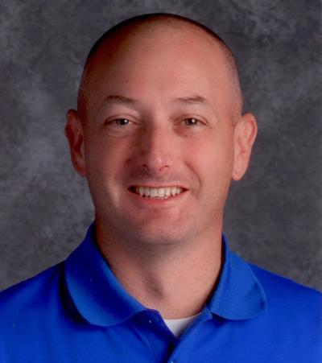**Travis Brenda**: Freshman Rep. Republican **(71st District)** Berea, Garrard, Maddison and Rockcastle Co. Beat out Jonathan Shell in the primary, and then trounced the Dem in the general election. Brenda, a math teacher at Rockcastle Co High School of 20 years, was upset and subsequently decided to run based on the state employees pension reform issue. Brenda is married with two younger children, a boy (10) and a girl (14). His biggest issues are, of course the pension issue, public education, economic development and the opioid crisis. He seems to be well intrenched in several local counties and school districts.   
Primary Sponsored Legislation: HB: 295  
Cosponsored Legislation: HB: 1, 5, 15, 28, 39, 54, 58, 75, 84, 150, 383 & 504

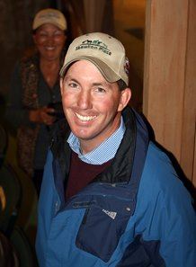**Matthew Koch**: Freshman Rep. Republican **(72nd District)** Bath, Bourbon, Fayette and Nicholas Co. Replacing Sannie Overly (Dem) who did not seek reelection. Owns a horse farm and is a Marine Vet. Married to a Bourbon Co Middle School teacher, they have 3 children. He is agra focused, but more than that is interested in job creation and bringing businesses into KY. Could be good for small business and work force development.

Primary Sponsored Legislation: HB: 133, 200, 212, 338 & 356  
Cosponsored Legislation: HB:1, 62, 136, 148, 175, 180, 197, 241, 295 & 311



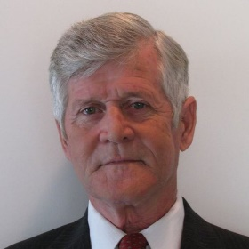

**Les Yates**: Freshman Rep. Republican **(73rd District)** Winchester KY, Clark and Madison Co. Les is taking over for Donna Mayfield who did not seek reelection. Yates, 65, prides himself on coming up poor in the mountains of eastern KY, putting himself through college and becoming a successful business owner and job creator. He was an electrician by trade but has owned and operated Boonesboro Supply for 17 years. His biggest issues are small business and job creation. He funded that vast majority of his campaign himself.   
Primary Sponsored Legislation: HB: 241  
Cosponsored Legislation: HB: 1, 136, 150, 180, 197 & 371

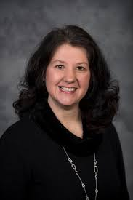**Deanna Frazier**: Freshman Rep. Republican **(81st District)** Richmond KY, Central Madison Co. She beat incumbent Wesley Morgan in the Rep primary, which resulted in Morgan endorsing the Dem candidate and filing a lawsuit for libel and slander. Frazier, a native of the area, is an audiologist by trade, and owns the Bluegrass Hearing Clinic. She is married with 2 children. She was awarded Small Business of the Year in 2016 by the Madison Co COC. Small business and job creation seem to be her biggest issues.

Primary Sponsored Legislation: HB: 150, 208, 229 & 279  
Cosponsored Legislation: HB: 1, 5, 25, 58, 61, 62, 64, 66, 84, 148, 159, 180, 249, 358 & 380

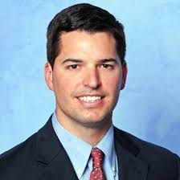**Adam Bowling**: Freshman Rep. Republican **(87th District)** Middlesboro KY, Bell and Harlan Co. Replacing Rick Nelson (Dem) who did not seek reelection. Bowling handedly won his race against the Dem nominee. He is the son of Mike Bowling, who held the seat in the 90’s. Medical Equipment Supply company owner. He is also the only republican in his family. He is a younger guy. Look for him to be a free thinker. Could be a great ally on medical issues.  
Primary Sponsored Legislation: HB:287, 396, 397 & 420  
Cosponsored Legislation: HB: 1, 62, 148, 180, 198, 224, 246, 249 & 456

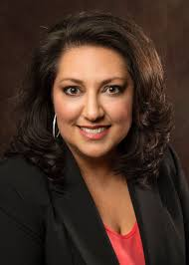**Cherlynn Stevenson**: Freshman Rep. Democrat **(88th District)** Lexington (South). Replacing Robert Benvenuti (Rep) who did not seek reelection. Won an incredibly tight race by 48 votes. She owns an event planning business in Lexington. She is the daughter of a coal miner and teacher. Her big issues are pension, public education and public health. Could help with buses, need to push the clean air front.

Primary Sponsored Legislation: HB: 424, 425, 426 & 427  
Cosponsored Legislation: HB: 17, 23, 24, 40, 58, 62, 64, 83, 85, 112, 113, 115, 126, 136, 137, 138, 155, 162, 164, 172, 175, 211, 237, 247, 253, 261, 273, 307, 310, 321, 322, 378, 383, 401 & 448



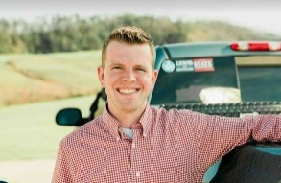**Derek Lewis:** Freshman Rep. Republican **(90th District)** London KY. Won unopposed in the general election after unseating incumbent Tim Couch in the primary in May 2018. Lewis is married with a one daughter. He is a “jack of all trades” so to speak. Lists himself first as entrepreneur and advocate for small business, which is not just good but also believable as he owns several in the area. He owns/operates his family business, which is a pharmacy, he also owns a commercial and residential property management company as well as a “handy-man” service, and to wrap it all up a “seasonal sales company”. He is/was the head of the county COC and seems. to be incredibly active in that. He also is involved in a number of local boards and charities. Big issues are the economy and job creation as well as a fiscally responsible government.

Cosponsored Legislation: HB: 62, 66, 136, 156*, 175, 198, 203, 249, 254, 327 & 488

Primary Sponsored Legislation: HB: 156, 219, 220 & 244

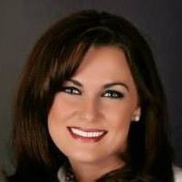

**Ashley Tackett Lafferty**: Freshman Rep. Democrat **(95th District)** Prestonsburg (Deep East KY). Thumped republican incumbent Larry Brown. ATL is trial attorney who attended UofL Law. As she is the daughter of teachers and coal miners, not unlike Stevenson, her big concerns are pension and public schools. However, she seems to ride the Dem party line as she is a trial attorney.

Primary Sponsored Legislation: HB: 469  
Cosponsored Legislation: HB: 15, 62, 75, 93, 111, 112, 113, 126, 261, 322, 401 & 406

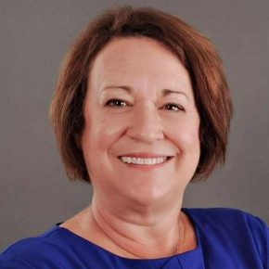

**Kathy Hinkle**: Freshman Rep. Democrat **(96th District)** Louisa KY, Carter and Lawrence Co. Won a super close election against the incumbent Jill York (Republican), by 6 votes. York had considered filing for a recount, however in early December 2018 decided against it. Hinkle, a native of Louisa KY and EKU alum. She was a staff member of the Lawrence CO BOE and then the ED of the KY Child Assault Prevention Agency. She is a mother to one adult daughter and has a grandchild. Hinkle ran on a platform of INCREASED corporate taxes, expanded gaming and higher and expanded sales taxes on specifically luxury items. Seems to be a new wave democrat (Bernie Sanders Doctrine) and will not be much help outside of being a polite vote should we need it. But it would seem based on articles and interviews she will vote for every possible tax available.  
Cosponsored Legislation: HB: 1, 12, 17, 23, 24, 40, 62, 64, 75, 83, 85, 112, 113, 115, 126, 136, 156, 162, 175, 198, 211, 253, 261, 273, 307, 310, 322, 350, 361, 401, 424, 425 & 426

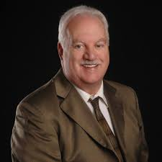**Bobby McCool**: Freshman Rep. Republican **(97th District)** Van Lear KY, Johnson, Morgan and Wolfe Co. Took over for Scott Wells (Republican) who did not seek reelection. McCool is the VP of the Big Sandy KCTCS. He is also a Marine Veteran as well as a former coal miner. He has spent the last 25 years in academia. His biggest issues are education and functional government, he seems to be very eastern KY centric.  
Primary Sponsored Legislation: HB:239, 266 & 267  
Cosponsored Legislation: HB: 25, 33, 60, 62, 64, 75, 148, 198 & 406

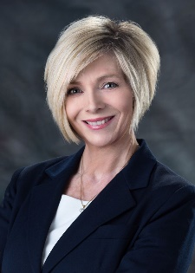**Terri Branham Clark**: Freshman Rep. Democrat **(100th District)** Catlettsburg KY, Boyd Co. Clark took over for the incumbent, Sinnette Democrat, who did not seek reelection. She has worked in non-profits, but currently owns a property management a real estate company in the greater Ashland area. She is a mother of 4 adult children, with 2 grandchildren. Her endorsements are very union heavy, almost exclusively so. Her biggest issues seem to be public education, the opioid issue and business and economic development. She seems to be a center left democrat. Could be a good lady to know.   
Primary Sponsored Legislation: HB: 53, 157, 332, 400 & 472  
Cosponsored Legislation: HB: 1, 21, 25, 40, 111, 112, 113, 126, 132, 136, 155, 162, 198, 239, 247, 253, 261, 263, 270, 273, 307, 310, 322 & 401